

**Year 12 Human Biology**

**Test: Homeostasis**

|  |
| --- |
| Name: **SOLUTIONS** |
| Teacher: |

|  |  |  |  |
| --- | --- | --- | --- |
|  | Marks Received | Marks Available | Percentage |
| Multiple Choice |  | 15 |  |
| Short Answer |  | 31 |  |
| Extended Answer |  | 12 |  |
| **TOTAL** |  | 58 |  |

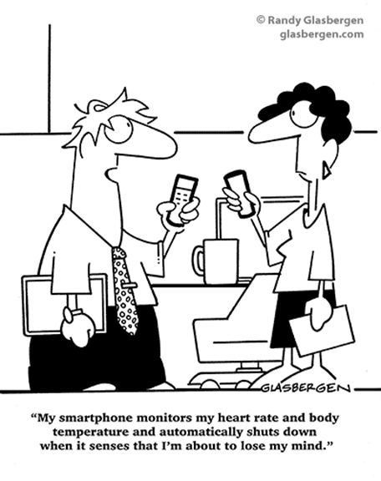

Weighting: 5% Assessment Time: 55 minutes

**MULTIPLE CHOICE SECTION 15 MARKS**

The following information relates to question 1 and 2.

Jamie and Quinn are enjoying some time prospecting for gold in the Outback. By the afternoon, the temperature rises to 41°C and they decide to finish their activities as they are both suffering from headaches and have run out of bottled water.

1. Temperature regulation in the boys’ bodies would involve
2. vasoconstriction to the arterioles of the muscle.
3. reduced nerve impulses to the sweat glands.
4. vasodilation of the arterioles of the skin.
5. increased sympathetic impulses to the adrenal medulla to trigger the release of noradrenaline.
6. The filtrate in the kidneys would
7. be altered as a result of less ADH circulating in the blood.
8. become more concentrated.
9. increase in volume.
10. have a higher proportion of water compared to the blood.
11. When the concentration of carbon dioxide returns to normal it would be reasonable to conclude that the
    1. respiratory muscles stop contracting.
    2. rate and depth of breathing decreases.
    3. number of afferent nerve impulses increase.
    4. respiratory centre in the brain fails to send efferent nerve impulses.
12. Negative feedback systems produce a response that:
13. reduces the strength of the stimulus message.
14. causes the stimulus to increase.
15. is different to that which would be expected to occur.
16. causes the stimulus to change in a way that is opposite to that of the original change.
17. Homeostasis:
18. keeps the endocrine system and nervous system equal to each other.
19. keeps a human’s internal environment at the same state as the external environment.
20. ensures nothing changes in the internal environment.
21. helps humans to be independent of the external environment.
22. Which of the following contributes to the gain of body heat?
23. Radiation to the surroundings.
24. Evaporation of sweat from the skin.
25. Radiation from surroundings.
26. Breathing out warm air.
27. Hydrogen ion concentration in the blood:
28. increases as a result of breathing.
29. increases as a result of increasing carbon dioxide concentration.
30. increases as a result of low oxygen levels.
31. is detected by chemoreceptors in the medulla oblongata.
32. Bouts of hyperglycaemia are common for people with type 1 diabetes. This is because:
33. a lack of glucagon means cells are not stimulated to take in glucose from the blood.
34. a lack of insulin means cells are not stimulated to take in glucose from the blood.
35. a lack of insulin causes blood sugar levels to drop below the level needed for normal body functioning.
36. even though they make insulin, their cells do not respond to it.
37. Following a high carbohydrate meal, blood glucose concentration increases and then decreases to below the normal level before settling at the normal level.

The reason that blood glucose concentration dips below the normal level before settling at normal is:

1. glucagon is only released when blood sugar concentration gets dangerously l
2. that this is an example of positive feedback.
3. the effects of insulin continue for some time after blood glucose has returned to normal.
4. blood glucose concentration in the liver is different from that in the pancreas.
5. Most body water is found:
6. in cells.
7. as blood plasma.
8. between cells.
9. in the alimentary canal.
10. Which of the following processes are controlled by positive feedback mechanisms?
    1. The contractions of the uterus during labour.
    2. The secretion of enzymes, peristalsis and blood supply of the gut when food is present.
    3. The control of carbon dioxide and oxygen levels during exercise.
    4. The control of balance, posture and locomotion when running a race.
11. When the body needs to remove excess carbon dioxide when levels are above normal limits, the effectors would be:
12. sympathetic nerves, which decrease breathing rate.
13. lung alveoli, which increase breathing rate.
14. the diaphragm, which decreases breathing rate.
15. respiratory muscles, which increase breathing rate.
16. During cycling practice, Evan notices his breathing rate dramatically increases.

The reason for this response is:

1. the pH level of his blood has increased, triggering his chemoreceptors.
2. the number of hydrogen ions in his blood has decreased causing a response coordinated by the medulla oblongata
3. chemoreceptors in the hypothalamus detected elevated levels of carbon dioxide.
4. the medulla oblongata sends increased impulses to the diaphragm and intercostal muscles.
5. Antidiuretic hormone is important in controlling water balance. The graph below shows changes in the concentration of antidiuretic hormone as plasma solute concentration changes.

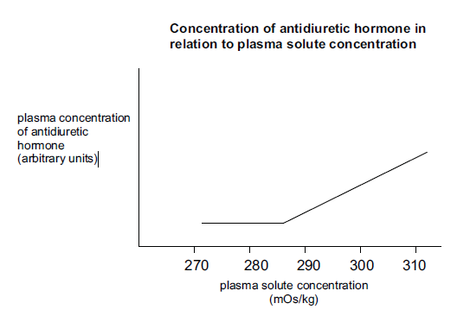

The change in antidiuretic hormone in the blood plasma at 285 mOs/kg was due to

1. an increase in osmotic pressure in the cells.
2. a decrease in the solute concentration of the plasma.
3. an increased intake of water into the cells.
4. a decrease in blood pressure in the plasma.
5. Which of these statements is NOT true regarding the temperature regulation function of the skin?
   1. As sweat evaporates from the skin, it carries away heat and drops body temperature.
   2. When body temperature increases, blood vessels in the epidermis dilate to transfer heat to the skin.
   3. The skin can lose heat by radiation, conduction, evaporation, or convection.
   4. If skin temperature falls below 10°C, blood vessels in the skin dilate.

**SHORT ANSWER SECTION TOTAL 31 MARKS**

**Question 16**

(a) When hyperventilation occurs, a person breathes faster and more deeply than normal.

(i) What effect would this have on the level of carbon dioxide in the blood?

(1 mark)

**CO2 levels will decrease**

(ii) Where in the brain would this change in carbon dioxide level be detected?

(1 mark)

**In the medulla oblongata**

(b) A girl had the pH levels in her blood taken immediately before and after swimming 500 metres in a pool. The results showed a drop in pH from 7.4 to 7.3. What caused this drop in pH to occur? (3 marks)

**Increases activity increases CO2 produced in cellular respiration**

**CO2 🡨 🡪 H2CO3 🡨🡪 H+  + HCO3- (Word equation acceptable)**

**As CO2  increases pH decreases / blood becomes more acidic**

(c) Describe the steps that need to occur so that more oxygen can be delivered to skeletal muscles when they become very active during exercise. (2 marks)

**Any two of the following**

**Increased rate / depth of breathing / dilation of bronchioles**

**Increased heart rate / cardiac output / blood pressure**

**Increase in blood flow to the muscles / vasodilation in the blood vessels of the muscles**

**Question 17**

A biologist is studying animal life in Antarctica, where the average daily temperature is -50°C. His work requires him to be in the open air making observations for long periods of time.

(a) Explain one (1) behavioural modification he would need to make, apart from wearing warmer clothing, when outside observing animals. Include in your answer how your chosen behaviour modification will help the biologist regulate his body temperature. (2 marks)

**• Continuous movement/ exercise – increase heat production in cellular respiration**

**• Consume hot food or drink – increase heat gain by conduction**

**• Huddling/curling to reduce SA exposed – reduce heat loss by convection and radiation**

**• Use hot packs - increase heat gain by conduction**

**• Seek shelter/ move out of cold winds – reduce heat loss by convection and radiation**

(b) Physiological mechanisms are also essential for the scientist to maintain his core temperature in these freezing conditions. Some of these are under nervous control and others are controlled by the endocrine system.

Name two (2) mechanisms that his nervous system would control and explain how they would maintain his core temperature. (2 marks)

**• Shivering – contraction of skeletal muscles producing heat**

**• Vasoconstriction of blood vessels in the skin – reduces blood flow to the skin and therefore reduces heat loss by convection and radiation**

(c) Two other biologists are studying other animal species in completely different conditions to that in Antarctica. One is in a hot desert and the other in a tropical rainforest. Both climates have a similar average daily temperature of 34° C. However, the biologist in the desert feels reasonably comfortable at this temperature, whereas the one in the tropical rainforest finds it very uncomfortable. Explain why. (2 marks)

**• Desert environment has a lower humidity / less water vapour in the air**

**• Sweating is more effective in desert environment as air is dry and water can evaporate – cooling biologist down quicker.**

**OR**

**• Tropical environment has a higher humidity / more water vapour in the air**

**• Sweating is less effective in tropical environment as air is saturated with water vapour and water cannot evaporate – biologist cannot cool down as efficiently**

(d) George was by no means an experienced biologist. He loved being outdoors and hiking but would often go walking with very little preparation. One day whilst out in the forest, a storm blew up and it started to rain. He slipped on the muddy track and fell down a ravine, badly injuring his leg. Unable to move, and dressed only in shorts and a T-shirt, he was trapped there overnight until he was found by hikers the next day. Briefly discuss the mechanisms of heat loss that would have contributed to his hypothermia. (3 marks)

**• Conduction – lying on the cold ground he would lose heat through contact**

**• Convection – exposure to rain / wind would increase heat loss**

**• Radiation – his body would lose heat without contact as his core body temperature is greater than his surroundings**

**Question 18**

Prior to having a morning operation a patient was told to fast (go without food) after an evening meal the night before. The graph below shows changes in the blood glucose concentration throughout the night, while the patient as resting, starting 30 minutes after the evening meal.

* 1. Describe how the above graph illustrates a negative feedback model. (2 marks)

**• Negative feedback produces a response in a direction opposite to the original stimulus**

**• Appropriate description with reference to the graph – eg. Following a meal blood glucose is high then reduces / reduces and then rises again due to glucagon**

* 1. On the same set of axes above, draw the blood glucose levels of a person suffering Type 2 diabetes (untreated) over this same time period. (1 mark)

**Line shows that glucose remain higher for longer and slowly decreases**

* 1. Explain the shape of your lined added to the graph in terms of blood glucose regulation. (3 marks)

**• Insulin is produced/ present but the cells don’t respond to insulin**

**• Therefore glucose levels remain higher for longer**

**• Until it is excreted by the body in the urine**

* 1. Diabetes can occur in both young and older people, although children usually require injections of insulin. Describe three symptoms of insulin dependent children and explain why each symptom would occur. (6 marks)

**(Any 3, 1 mark for symptom, one for explanation)**

**• tiredness / lethargy – cells do not take up glucose so cell respiration /metabolism is low**

**• thirsty – higher glucose concentration in the blood so relative water concentrations decrease / high water loss due to frequent urination, stimulating the thirst centre in the hypothalamus**

**• loss of weight – fat is utilised as an energy source for cell respiration as cells are starved of glucose**

**• frequent urination – nephron unable to reabsorb water due to high glucose concentration in the filtrate.**

**• glucose in the urine – as cells do not take up glucose, blood levels are much higher and not all of it can be reabsorbed from the nephron**

* 1. The pancreas is the main endocrine gland for blood glucose regulation. Name another hormone which can affect blood glucose levels, state the endocrine gland where it is produced and released and explain its’ effect on blood glucose levels. (3 marks)

**• Adrenaline produced in the adrenal medulla**

**• Increases blood glucose**

**• By stimulating glycogenolysis in the liver and skeletal muscles**

**OR**

**• Cotrisol produced by the adrenal cortex**

**• Increases blood glucose**

**• By stimulating glycogenolysis in the liver and skeletal muscles and gluconeogenesis in the liver**

**EXTENDED ANSWER SECTION 12 MARKS**

**Question 19**

If you carry out a high level of physical activity, the osmotic pressure in your cells is increased, stimulating two types of feedback mechanisms that enable your cells to regain optimum water levels. In the situation described above, explain how homeostasis is maintained by

(i) hormonal control (8 marks)

(ii) conscious action (4 marks)

1. **Hormonal** **Control – may discuss ADH or aldosterone**

**• Osmoreceptors in the hypothalamus detect high osmotic pressure/low water concentration in the blood and**

**• Send an impulse to the posterior pituitary gland to signal the release of ADH into the bloodstream**

**• Use of full name of the hormone the first time (ADH = antidiuretic hormone)**

**• ADH is detected by the tubules of the nephron and**

**• Increases re-absorption of water from the distal convoluted tubule and collecting duct by**

**• Increasing their permeability of the tubule wall**

**• Moving water from the filtrate into the renal blood capillaries**

**• Osmotic gradient is created by the high concentration of ions in the renal medulla**

**• The reabsorption of water in the nephron decreases osmotic pressure of the blood**

**• Sends an impulse to the anterior pituitary gland signally the production and release of ACTH into the blood stream**

**• Use of full name of the hormone the first time (ACTH = adrenocorticotropic hormone)**

**• ACTH causes the Adrenal Cortex to release aldosterone into the bloodstream**

**• Aldosterone is detected by the tubules of the nephron and**

**• Increases the reabsorption of sodium ions in the distal convoluted tubule and collecting duct**

**• Consequently moving water from the filtrate into the renal blood capillaries**

**• Osmotic gradient is created by the high concentration of sodium in the renal blood capillaries**

**• The reabsorption of water in the nephron decreases osmotic pressure of the blood**

1. **Conscious action**

**• Osmoreceptors in the hypothalamus detect high osmotic pressure / low water concentration in the blood and**

**• Thirst centre in the hypothalamus sends and impulse to the cerebral cortex**

**• A conscious feeling of thirst occur causing the person to drink**

**• Water is absorbed from the alimentary canal into the blood stream**

**• Resulting in a decrease of osmotic pressure of the blood**